Yugandhar Reddy B R
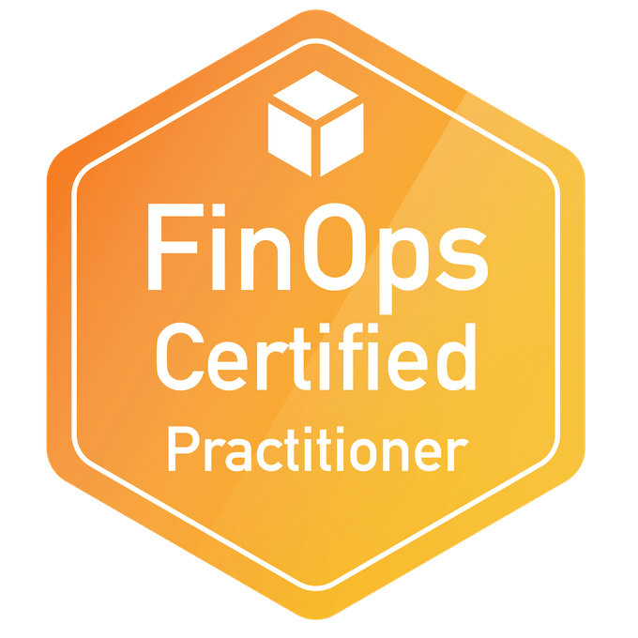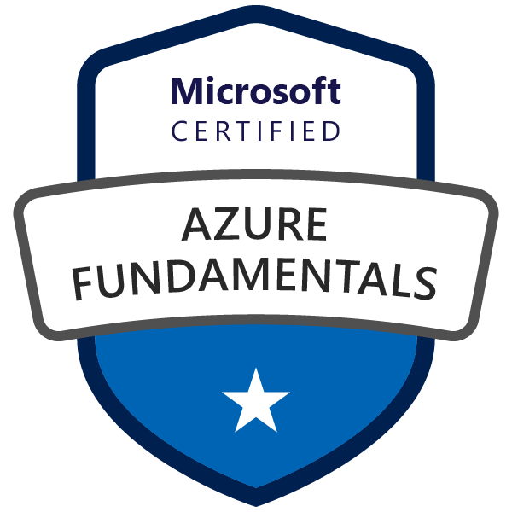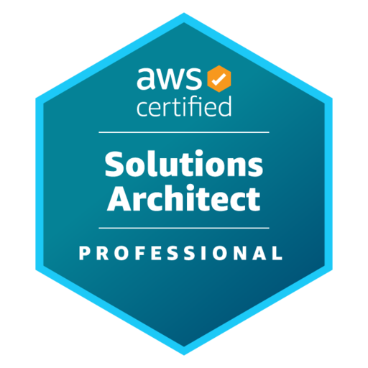
Lead Cloud Solutions Architect | Devops architect
Phone: +1 848-480-6418
Email: yugandharbolla0@gmail.com
PROFESSIONAL SUMMARY

- Proficient cloud expert, holding AWS Solutions Architect Professional certification, demonstrating advanced expertise in designing and deploying scalable, highly available, and fault-tolerant systems on AWS.
- Over 10 years of experience in IT, with a strong focus on designing and implementing secure, scalable, and cost-optimized solutions across AWS. Proven success in leading enterprise cloud migrations and hybrid cloud strategies.
- Leveraged comprehensive AWS knowledge to architect and implement complex cloud solutions for major clients, including BMW, VW, and MAN, showcasing the ability to apply best practices in real-world scenarios.
- Demonstrated mastery of Infrastructure as Code (IaC) principles using Terraform, enabling rapid, consistent, and version-controlled deployment of cloud resources across multiple environments and providers.
- Designed and executed large-scale cloud migration strategies, transitioning critical applications from on-premise to AWS infrastructure, utilizing a deep understanding of AWS services and architecture principles.
- Implemented advanced multi-cloud solutions, combining expertise in AWS (as an AWS Certified Solutions Architect and SysOps Administrator) with knowledge of Azure (certified in Azure Fundamentals), to create robust and flexible cloud environments.
- Architected SaaS integrations leveraging APIs and cloud-native services to unify applications across AWS and Azure environments.
- Architect and build AWS-based data engineering frameworks using Glue, EMR, Redshift, Lambda, S3, and Terraform, enabling efficient, compliant, and scalable enterprise data solutions. Implemented Snowflake-based data warehouses integrated with AWS Glue ETL jobs for seamless data ingestion, transformation, and analytics.
- Utilized FinOps principles (as a FinOps Certified Practitioner) to optimize cloud costs and maximize ROI for enterprise-level projects, balancing performance requirements with budget constraints.
- Architected high-performance, scalable solutions leveraging AWS services including ECS, SNS, Lambda, and Aurora, demonstrating proficiency across the AWS ecosystem.
- Led complex database migration projects, including Oracle to Aurora and Oracle to RDS Oracle transitions, using AWS Database Migration Service (DMS) and Schema Conversion Tool (SCT), showcasing database expertise alongside cloud skills.
- Implemented containerization strategies with ECS, EKS, and AKS, and designed next-generation Kubernetes infrastructure for automotive clients, highlighting advanced container orchestration skills.
- Led the migration of Kubernetes workloads from AWS EKS to on-premise, implementing Ceph for resilient storage and Vault for secure secret management, aligning with enterprise data residency and compliance requirements.
- Developed serverless architectures using AWS Lambda, creating efficient, scalable, and cost-effective solutions for data processing and application logic, with Python as the primary language for Lambda functions.
- Established robust CI/CD pipelines integrating Jenkins, GitLab CI, GitHub, and Bitbucket with AWS tools (CodePipeline, CodeBuild), leveraging Shell and Python scripts for build, test, and deployment automation.
- Designed and implemented hybrid connectivity solutions between on-premise and AWS environments, showcasing the ability to create seamless integrations for enterprise clients.
- Implemented advanced security measures in cloud environments, including IAM policies, encryption mechanisms, and Single Sign-On (SSO) solutions for AWS and Azure, ensuring compliance and data protection.
- Consistently applied best practices in cloud architecture, security, and operations, as validated by multiple AWS certifications, while leveraging Terraform, scripting skills (Python, Shell), and open-source tools to deliver innovative, highly automated, and efficient cloud solutions across various industries.
- Spearheaded RFPs and tender offers to secure multiple high-value cloud projects, driving substantial business growth and establishing the company as a prominent player in the cloud services market.
- Designed and implemented EKS to On-Prem OpenShift migration, including configuring Ceph for persistent storage and Vault for secrets management, enabling a seamless, secure hybrid Kubernetes environment.
- Collaborated with cross-functional teams, including application developers, DevOps engineers, and enterprise architects, to modernize legacy mainframe and Java applications, enabling smooth transitions to cloud-native platforms using Docker, Kubernetes, and services such as AWS Fargate.
- Enabled real-time data analytics pipelines using services such as AWS Glue, Athena, and S3, integrated with Lambda functions and CloudWatch for data processing, monitoring, and alerting.
- Led cloud knowledge-sharing initiatives, conducting internal workshops, mentoring junior engineers, and contributing to internal documentation, playbooks, and best practice guidelines to uplift overall cloud maturity within the organization.

EDUCATION
- Master of Science in Flexible Electronics from Technical University of Chemnitz, Germany
- Bachelors in Electronics and computer science from Jawaharlal Nehru Technological University

TECHNICALSKILLS
Cloud Platforms | AWS: EC2, S3, Lambda, API Gateway, Athena, Glue, DMS, SCT, RDS, CloudFormation, ECS, CloudWatch, SQS, SNS, Amazon Q, BedRock, KMS  Azure: App Services, Key vault, function app, Blob storage, Azure Active Directory (Azure AD), Service Bus, Azure Container Registry (ACR) and Azure Kubernetes service (AKS), Azure SQL, Azure Cosmos DB
IaC & Automation | Terraform, CloudFormation
Containerization & Orchestration | Docker, Kubernetes, OpenShift, ECS, ECS, AKS, AWS Fargate
CI/CD | Jenkins, GitLab CI, Concourse CI, AWS CodePipeline, AWS CodeBuild
Version Control | Git, GitHub, Bitbucket, SVN
Monitoring & Logging | Prometheus, Grafana, ELK Stack (Elasticsearch, Logstash, Kibana), Zabbix
Programming & Scripting | Python, Bash, Shell Scripting
Security & Compliance | IAM, Keycloak, HashiCorp Vault, AWS Security Hub, Azure Security Center
Databases | Oracle, Aurora, PostgreSQL, MongoDB, DynamoDB, Redis
Serverless Frameworks | AWS Lambda, AWS SAM, Serverless Framework
APIs & Integration | Swagger, Postman, REST API, SOAP, OAuth2, Messaging Queues
Configuration Management | Ansible, Puppet
Code Editors | Visual Studio Code (VS Code), Sublime Text, Atom, Notepad++, Vim
Operating Systems | Linux, Unix, Windows
Cost Management (FinOps) | AWS Cost Explorer, Azure Cost Management, FinOps Principles
SDLC Methodologies | Agile, Scrum, Waterfall
CERTIFICATIONS:

- AWS Certified Solutions Architect - Professional
- AWS Certified Solutions Architect – Associate
- AWS Certified SysOps Administrator - Associate
- CNCF Certified FinOps Practitioner
- Microsoft Certified Azure Fundamentals

WORKING EXPERIENCE:
Client : AT&T, Dallas TX May 2025- Till Date
Role: Senior Cloud Solutions Architect (DevOps) - Cloud Migration & Network Integration (AWS)

Project Description:
As Senior Cloud Solutions Architect, led the end-to-end AWS migration and modernization of AT&T’s Fleet Complete platform, a large-scale fleet analytics and management system. The initiative modernizes legacy monolithic workloads into headless, API-driven architectures, integrates AIOps-based observability, and enforces IAM ring-fencing across multi-account AWS environments. Designed a secure hybrid cloud model connecting AT&T NetBond for Cloud with AWS Direct Connect, improving scalability, performance, and governance across business units.
Responsibilities :
- Redesigned monolithic workloads into headless, event-driven architectures using API Gateway, AWS Lambda, and microservices, enabling multi-channel integrations and reducing release coupling by 45%.
- Directed enterprise-scale migration leveraging AWS Migration Hub, Application Migration Service (MGN), and Database Migration Service (DMS), achieving zero-data-loss cutover and full compliance with AT&T internal policies.
- Implemented AIOps-driven observability frameworks integrating metrics, logs, and traces for predictive monitoring, automated root-cause correlation, and anomaly detection, reducing MTTR by 35%.
- Deployed IAM ring-fencing controls using Service Control Policies (SCPs), Permission Boundaries, and Attribute-Based Access Control (ABAC), enforcing least-privilege principles and secure workload isolation per environment.
- Architected multi-account governance via AWS Organizations, Control Tower, and Landing Zone, enabling centralized policy management, auditing, and FinOps alignment.
- Designed hybrid connectivity frameworks integrating MPLS VPN, NetBond, Direct Connect, and Transit Gateway, improving network performance and reliability by 40% under zero-trust principles.
- Built intelligent CI/CD pipelines with Copado, GitHub Actions, and Terraform, embedding automated compliance gates, static code checks, and release governance.
- Automated environment provisioning, post-migration validation, and monitoring through Lambda, CloudWatch, and Config, accelerating deployment timelines by 70%.
- Applied FinOps optimization using Trusted Advisor and Cost Explorer, reducing operational costs by 25% via rightsizing and proactive scaling insights.
- Collaborated with security and analytics teams to strengthen compliance posture and improve operational dashboards for real-time fleet utilization insights.
Environment: AWS, Azure, Kubernetes, Docker, API Gateway, Lambda, EKS, ECS, CloudWatch, CloudTrail, Config, Migration Hub, Application Migration Service, DMS, Organizations, Control Tower, Landing Zone, Trusted Advisor, Cost Explorer, GitHub Actions, Terraform, Ansible, CloudFormation, Copado, Prometheus, ELK, X-Ray, Jaeger, Lucidchart, Draw.io, Microsoft Visio, Word, Excel, PowerPoint, SharePoint, Teams, Confluence, Jira, Microsoft Project, Adobe Acrobat Pro, Tableau, JSON, YAML, Bicep, NetBond, MPLS VPN, Direct Connect, Transit Gateway

Project Description
BundesNetzAgentur, Sulzer GmbH, Munich, Germany Jan 2024 to May 2025
Role: Senior Cloud Solutions Architect/ Devops architect
Project Description
Responsible for designing and implementing a modern network services monitoring platform for the Bundesnetzagentur to track and present nationwide coverage data for Cellphone, DSL, and Fiber services reported biannually by network providers. The system ensures public transparency and accessibility by building a system capable of aggregating and visualizing large-scale data. Played a key role in modernizing the infrastructure using technologies such as Docker, Kubernetes, ArgoCD, Grafana, Prometheus, and the ELK stack to achieve high availability, scalability, and comprehensive monitoring in line with regulatory objectives.
Responsibilities:
- Designed and developed a scalable microservices-based platform to aggregate and visualize network coverage data (Cellular, DSL, and Fiber) reported biannually by national providers.
- Architected and automated CI/CD pipelines using Ansible, GitHub Actions, Docker, and Kubernetes (EKS), ensuring seamless container orchestration, environment provisioning, and automated deployments across multiple environments.
- Implemented GitOps-based workflows with ArgoCD and Helm, enabling declarative deployments, version-controlled manifests, and automated environment synchronization.
- Configured Kubernetes add-ons and cluster components including Ingress Controllers (NGINX, AWS ALB), Horizontal Pod Autoscalers, and Cluster Autoscaler, optimizing performance and cost efficiency.
- Integrated Service Mesh (Istio) for traffic management, mutual TLS authentication, and observability, improving inter-service security and visibility.
- Implemented advanced observability and monitoring solutions using:
  - Metrics: Prometheus, Grafana, Kube-State-Metrics, Node Exporter for real-time system and application performance monitoring.
  - Logs: ELK Stack (Elasticsearch, Logstash, Kibana) and Fluent Bit for centralized log collection, parsing, and visualization.
  - Traces: Jaeger and OpenTelemetry for distributed tracing and latency analysis across microservices.
- Developed serverless functions using AWS Lambda for asynchronous event handling and background task automation, optimizing scalability and resource utilization.
- Implemented secure service-to-service communication via OAuth 2.0, mTLS, and AWS Secrets Manager, ensuring robust authentication and credential protection.
- Deployed and managed Linux virtual machines using VMware vCenter, standardizing VM templates and automating infrastructure maintenance tasks.
- Applied automated code quality and security scanning using SonarQube, Trivy, and GitHub Actions, enforcing compliance, dependency hygiene, and vulnerability remediation.
- Created and maintained architecture diagrams and workflow documentation using Lucidchart, Draw.io, and Microsoft Visio to visualize Kubernetes topologies, CI/CD pipelines, and cloud environments across AWS, Azure, and GCP.
- Authored and maintained comprehensive technical documentation including infrastructure design, deployment procedures, and incident response runbooks.
- Improved stakeholder collaboration by visualizing complex technical workflows, enabling non-technical teams to understand cloud architecture decisions and system health.
Environment: OpenShift, Kubernetes, Docker, ArgoCD, Ansible, GitHub Actions, YAML, Ceph, HashiCorp Vault, Prometheus, Grafana, Elastic Stack (ELK), AWS Lambda, AWS S3, CloudWatch, REST API, OAuth2, Git, Python Scripts, Linux, SonarQube, Microservices Architecture
BMW AG, Sulzer GmbH, Munich, Germany Feb 2022 to Dec 2023
Role: Senior Cloud Solutions Architect\ Devops architect
Project Description
Responsible for migrating the Service Shadow application and its underlying Oracle database from BMW’s on-premises infrastructure to AWS. The project involved modernizing a critical internal service that processes real-time data notifications from a gateway, applying proprietary business logic, and exposing the processed data to external systems. The application was containerized and deployed on AWS ECS for high availability, while the database was migrated to Amazon RDS Aurora to ensure scalability, reliability, and managed operations.
Responsibilities:
- Conducted a comprehensive assessment of BMW’s on-premises architecture, analysing existing technology stacks, interdependencies, and workloads to identify modernization opportunities.
- Selected and architected AWS cloud services including EC2, S3, RDS, VPC, IAM, and CloudWatch to align with business and technical requirements, ensuring scalability, security, and cost efficiency.
- Developed a tailored migration strategy that minimized downtime and maintained data integrity throughout the transition.
- Refactored and containerized application components using Docker, preparing workloads for deployment in ECS/EKS environments.
- Led the migration of databases from Oracle to Amazon Aurora PostgreSQL, managing schema conversion, data validation, and cutover execution.
- Designed and implemented CI/CD pipelines using Terraform and GitHub Actions to automate infrastructure provisioning and application deployment workflows.
- Configured and optimized AWS networking components including VPCs, subnets, NAT gateways, and security groups to enable a secure and scalable environment.
- Integrated SaaS platforms such as CRM, ITSM, and analytics tools, streamlining operations and reducing manual dependencies across departments.
- Set up monitoring and observability solutions using AWS CloudWatch, CloudTrail, and Prometheus for system reliability, metrics collection, and log analytics.
- Applied performance tuning and load testing to ensure compliance with BMW’s SLAs and quality benchmarks.
- Created version-controlled architecture and UML diagrams using Lucidchart and Draw.io to maintain accurate, real-time infrastructure documentation.
- Documented best practices for cloud architecture, migration, and operations, supporting knowledge transfer and ongoing environment optimization.
- Utilized VMware vSphere suite (ESXi, vCenter Server, vRealize, vMotion, DRS, HA) for managing and migrating legacy workloads before cloud transition.

Environment: Quarkus, AWS Cloud (ECS, S3, VPC, Lambda, API Gateway, Route53, CloudFront, ElastiCache, DynamoDB, RDS, IAM, Parameter Store, Systems Manager), VMware, vCenter, Terraform, Docker, Java, PostgreSQL, DMS, REST/SOAP, Git Actions, Code Pipeline, Code build, SQS, SNS

MAN Truck and Bus SE, Sulzer GmbH, Munich, Germany Oct 2022 to Jul 2023
Role: Senior Cloud Solutions Architect
Project Description
Responsible for leading the Oracle Database Migration & Generator Modernization project for MAN Truck & Bus SE, overseeing the transition of on-premises Oracle databases to Amazon RDS for Oracle using AWS Database Migration Service (DMS). The project involved designing and implementing the DMS replication architecture, configuring full and ongoing data migration tasks, and ensuring secure, scalable infrastructure through Terraform, Ansible, IAM, and KMS. Additionally, I rearchitected legacy data generators into cloud-native Python services, improving performance, maintainability, and integration with the new cloud environment. I also established monitoring and alerting with Amazon CloudWatch and worked closely with cross-functional teams to validate schema compatibility, optimize SQL performance, and ensure a smooth cutover with minimal disruption.

Responsibilities:
- Executed end-to-end migration of Oracle databases to Amazon RDS for Oracle using AWS DMS, achieving minimal downtime.
- Designed and implemented DMS replication architecture, configuring tasks for full and ongoing data replication.
- Performed ESXi host configuration, patch management, and firmware updates to maintain security and performance compliance.
- Re-architected legacy data generators as cloud-native services using Python, improving data simulation workflows and system integration.
- Provisioned infrastructure using Terraform and automated environment configuration through Ansible.
- Monitored migration and database performance using Amazon CloudWatch, ensuring operational integrity post-migration.
- Applied IAM, KMS, and parameter group policies to secure and fine-tune RDS instances.
- Collaborated with DBA and DevOps teams to validate schema compatibility and optimize SQL performance in the new environment.
- Documented the entire migration process and created knowledge-transfer materials to support operations and future enhancements.
Environment: AWS RDS for Oracle, AWS DMS, AWS SCT, Flyway, Terraform, Ansible, Python, Oracle DB (on-prem), Amazon CloudWatch, IAM, KMS, Git, YAML, Linux, PgAdmin, Mysql workbench

BMW AG, Sulzer GmbH, Munich, Germany Feb 2021 to May 2022
Role: Senior Cloud Solutions Architect
Project Description
Responsible for supporting the Cloud Data Hub (CDH) initiative—a joint effort by BMW, Sulzer, and AWS—designed to enable large-scale migration of over 200 applications to AWS and enhance Data Lake capabilities. Contributed to refactoring selected applications for cloud-native compatibility using a "Factory Approach" and automated infrastructure provisioning with Terraform and CloudFormation. Executed data migration using AWS Glue, DMS, and S3, and built CI/CD pipelines with GitLab and Jenkins. Leveraged AWS services such as Athena, RDS, DynamoDB, and CloudWatch for performance optimization, while using Python for automation and integration tasks.
Responsibilities:
- Automated the setup process and defined Infrastructure as Code (IaC) templates to streamline deployment and management.
- Prepared and structured data, including conceptualizing data storage solutions to support optimal cloud data management.
- Executed the migration of data and refactored on-premises applications for cloud-native optimization, ensuring compatibility with AWS services.
- Developed and implemented deployment strategies, including integration testing, to ensure smooth transitions and operational integrity.
- Applied a "Factory Approach" to refactor applications for the new cloud environment and managed their migration to AWS.
- Utilized AWS services such as S3, Glue, DynamoDB, DMS, Athena, RDS, and CloudWatch to build and maintain the cloud infrastructure.
- Leveraged Python for scripting and automation tasks.
- Used Bitbucket, GitLab, and Jenkins for version control and continuous integration/continuous deployment (CI/CD) pipelines.
- Implemented service management processes using ServiceNow.
- Employed Terraform and CloudFormation for infrastructure provisioning and management.
- Managed documentation and project tracking using Confluence and Jira to facilitate collaboration and progress monitoring.
Environment: AWS S3, AWS Glue, AWS DynamoDB, AWS DMS, AWS Athena, AWS RDS, AWS CloudWatch, Terraform, AWS CloudFormation, Python, Bitbucket, GitLab, Jenkins, ServiceNow, Confluence, Jira, YAML, Linux, CI/CD Pipelines, Infrastructure as Code (IaC), Microservices Architecture

BMW AG, Sulzer GmbH, Munich, Germany Aug 2021 to Feb 2022
Role: Senior Cloud Solutions Architect
Project Description
Responsible for supporting the “Local Cloud Data Hub – Data Focus” project, aimed at extending the CDH platform by integrating multiple merchant interfaces across Germany. The project involved migrating seven key interfaces to AWS, focusing on data related to offers, discounts, sales, and inventory. Contributed to the integration of these interfaces with the CDH platform to enhance data availability and support business analytics. Supported infrastructure automation using Terraform and CloudFormation, and enabled efficient data processing with AWS services such as Glue, S3, and Athena. Worked alongside the main CDH initiative to ensure consistency and reuse of cloud-native patterns.
Responsibilities:
- Developed and implemented the infrastructure necessary for connecting local cloud data hub interfaces to the newly developed Centralized Data Hub (CDH), a centralized storage solution for BMW's extensive data needs, enabling streamlined data management across the organization.
- Engineered seamless integration for seven distinct interfaces by connecting them to the CDH, ensuring efficient data ingestion, processing, and storage to support data-driven decision-making.
- Utilized Terraform to define Infrastructure as Code (IaC), automating the setup and deployment process for consistent and scalable infrastructure provisioning across the cloud environment.
- Leveraged AWS services, including S3, Athena, Glue, and Step Functions, to manage and process the data ingested into the CDH, optimizing data flow, improving scalability, and ensuring high-performance data operations.
- Enabled cross-platform analytics by connecting Snowflake with BI tools such as Tableau and QuickSight for unified enterprise reporting.
- Designed and maintained the data architecture, utilizing DynamoDB to store and manage process information, ensuring reliable tracking and accessibility of data operations while maintaining data integrity across systems.
- Managed source code and version control through GitHub, ensuring collaborative development, continuous integration, and seamless deployment of infrastructure and application updates.
- Implemented comprehensive data governance practices, including the modeling and application of interfaces, access controls, and abstraction layers within the CDH, facilitating secure and seamless data interaction and integration.
- Collaborated with cross-functional teams using Jira for project management and Confluence for documentation, ensuring alignment with business requirements, enhancing the overall efficiency of data processing workflows, and contributing to the successful execution of the project.
Environment: AWS Glue, Snowflake, Quicksight, Athena, Lambda, Step Functions, S3, RDS, Python Scripting, Terraform, CloudWatch, Confluence, Bitbucket, Jira
Volkswagen AG, Sulzer GmbH, Munich, Germany Jan 2020 to Jul 2021
Role: Senior Cloud Solutions Architect
Overview:

Responsible for leading the migration of VW’s SAP S/4HANA ERP system from on-premises infrastructure to AWS, aiming to enhance scalability, performance, and business process integration. Deployed SAP S/4HANA in a cloud-optimized environment by configuring secure and high-availability AWS components including EC2, EBS, and VPC. Ensured the infrastructure met SAP’s performance and reliability standards, enabling seamless enterprise operations and future scalability on the AWS cloud.

Responsibilities:
- Developed a comprehensive migration strategy, including detailed project planning, risk assessment, and timeline management, to ensure a smooth transition of SAP S/4HANA from the on-premises environment to AWS.
- Executed the deployment and configuration of SAP S/4HANA on AWS, ensuring the seamless migration of ERP data and applications while maintaining data integrity and minimizing operational disruption.
- Designed and implemented the AWS cloud architecture to support SAP S/4HANA, including the setup and optimization of AWS services such as EC2, RDS, S3, and CloudFront to achieve optimal performance and scalability.
- Integrated SAP S/4HANA with other enterprise systems, including CRM and ERP solutions, to ensure efficient data flow and process integration within the AWS cloud environment.
- Conducted thorough testing, including functional, performance, and security evaluations, to validate the AWS-based SAP S/4HANA setup and ensure it met BMW’s operational requirements.
- Provided training and support for BMW’s IT and business teams on managing SAP S/4HANA in the AWS environment, and developed comprehensive documentation for ongoing maintenance and future enhancements.
- Implemented best practices for cloud operations, including automated backups, scaling policies, and monitoring using AWS CloudWatch to maintain high availability and performance of the SAP S/4HANA deployment.
Environment: SAP S/4HANA on AWS, AWS EC2, RDS, S3, CloudFront, CRM, ERP, Jenkins, Git, Confluence, Jira, Python, Cloud Formation

Sulzer GmbH, Munich, Germany Jun 2019 - Jul 2020
Role: Solutions Architect/Cloud Engineer
Project Description
Spearheaded the adoption of cloud infrastructure at Sulzer through the strategic deployment of AWS Landing Zones, establishing robust and scalable cloud frameworks tailored to support diverse organizational units. Orchestrated the implementation of Keycloak as the enterprise-wide cloud Single Sign-On platform, seamlessly connecting it with the organization's Microsoft Azure-hosted LDAP infrastructure to deliver unified authentication capabilities across multi-cloud environments using established corporate identity credentials. Streamlined user provisioning processes by integrating OTRS ticketing system with automated account creation workflows, dramatically minimizing administrative overhead and accelerating employee onboarding cycles. Additionally, developed and executed an extensive internal education initiative focused on AWS certification preparation, encompassing Cloud Practitioner and Solutions Architect

Responsibilities:
- Architected comprehensive AWS Landing Zone frameworks to establish secure, scalable cloud infrastructure customized for various organizational divisions, ensuring each unit received appropriate resource allocation and access controls aligned with their operational requirements.
- Implemented Keycloak as the enterprise Single Sign-On platform to centralize user authentication across hybrid cloud environments, establishing seamless integration with Azure-hosted LDAP services to enable corporate credential utilization for unified access management.
- Developed and maintained secure, scalable SaaS integrations using REST APIs, OAuth, and event-driven architectures.
- Designed and delivered an extensive cloud education initiative featuring interactive workshops and practical laboratory sessions to advance employee competency in cloud technologies and industry best practices.
- Mentored and coached personnel pursuing AWS professional certifications, specifically Cloud Practitioner and Solutions Architect Associate credentials, through structured guidance, curated learning resources, mock assessments, and individualized support.
- Established comprehensive documentation frameworks covering cloud governance standards, security protocols, and operational guidelines to facilitate ongoing cloud environment administration and management.
- Conducted regular knowledge transfer sessions and educational workshops to ensure organizational awareness of emerging cloud technologies and contemporary methodologies.
- Assessed and optimized training program effectiveness through continuous evaluation and iterative improvements to address knowledge gaps and enhance learning outcomes.
Environment: AWS, AWS Landing Zones, Keycloak, Single Sign-On (SSO), Azure LDAP, Python, Terraform, Code Pipeline, Code Commit, Code Build, Code Deploy

Volkswagen, Reply GmbH, Germany Aug 2018 - Feb 2019
Role: Cloud Native Solutions Architect for Volkswagen
Project Description
Responsible for architecting and building a next-generation Kubernetes infrastructure for Volkswagen’s infotainment system. The objective was to enhance the scalability, reliability, and efficiency of the infotainment platform using modern Kubernetes technologies. This included designing and deploying a robust Kubernetes environment, integrating Concourse for CI/CD, and leveraging the ELK Stack for monitoring and logging.
Responsibilities:
- Architected and implemented a state-of-the-art Kubernetes infrastructure to support Volkswagen’s infotainment system, ensuring the platform could scale efficiently and handle high workloads.
- Designed and configured Kubernetes clusters using Terraform to automate the deployment and management of the infrastructure, ensuring consistency and reducing manual effort.
- Integrated Concourse CI/CD pipelines to streamline continuous integration and delivery processes, enabling automated testing, building, and deployment of applications within the Kubernetes environment.
- Incorporated the ELK Stack (Elasticsearch, Logstash, and Kibana) into the Kubernetes environment for advanced logging, monitoring, and visualization of system performance and operational metrics.
- Developed and applied best practices for Kubernetes deployments, including container orchestration, service discovery, and network policies to optimize the performance and reliability of the infotainment system.
- Collaborated with cross-functional teams to ensure seamless integration of the Kubernetes infrastructure with existing systems and applications, addressing any compatibility issues and ensuring smooth operation.
- Implemented security measures for the Kubernetes environment, including role-based access control (RBAC), network policies, and secure communication practices to protect sensitive data and maintain system integrity.
Environment: Kubernetes, Terraform, Concourse, ELK Stack (Elasticsearch, Logstash, Kibana), Docker, AWS, Oracle DB, Direct Connect

Ferrero GmbH, Reply GmbH, Germany Jun 2018 - Sep 2018
Role: Cloud Native Solutions Architect for Volkswagen
Project Description
Responsible for deploying and monitoring the infrastructure for the SAP Hybris application, focusing on automating the deployment of environments and the eCommerce Hybris application for both B2B and B2C use cases across development, QA, and production environments. The project aimed to streamline and automate the deployment process, ensuring consistency and efficiency across all stages of the software lifecycle.

Responsibilities:
- Developed and implemented automated deployment strategies for SAP Hybris applications across development (Dev), quality assurance (QA), and production (Prod) environments using AWS CloudFormation and Troposphere.
- Configured and managed infrastructure for SAP Hybris applications, including setup of environments for both B2B and B2C eCommerce functionalities, ensuring reliable and scalable deployment processes.
- Utilized Puppet for configuration management, automating the setup and maintenance of servers and application components to ensure consistency and reduce manual intervention.
- Integrated Zabbix as the monitoring tool to oversee the health and performance of the deployed infrastructure and applications, enabling proactive detection and resolution of issues.
- Designed and implemented CloudFormation templates to automate infrastructure provisioning, allowing for repeatable and reliable deployment processes.
- Collaborated with cross-functional teams to ensure seamless integration and deployment of SAP Hybris across different environments, addressing any issues that arose during deployment and ensuring alignment with project requirements.
Environment: AWS EC2, S3, VPC, CloudFormation, Troposphere, Puppet, SAP Hybris, Zabbix

Fraunhofer ENAS, Germany Sep 2015 – Dec 2016
Role: Cloud Engineer
Project Description
Responsible for automating infrastructure provisioning and improving system observability as part of a foundational cloud enablement project. Focused on standardizing deployment workflows, ensuring consistent infrastructure across development and testing environments, and implementing baseline monitoring solutions to support scalability and operational transparency.
Responsibilities:
- Developed and maintained Terraform scripts to provision and manage AWS infrastructure components like EC2, S3, and VPC.
- Automated routine tasks using Shell scripts, such as log rotation, backup validation, and disk usage monitoring.
- Performed basic Linux system administration tasks, including user management, file permissions, service restarts, and log analysis.
- Managed cron jobs to schedule automated health checks and maintenance scripts on Linux servers.
- Supported CI/CD pipeline setup using Jenkins for automating application deployments and infrastructure updates.
- Collaborated with senior engineers to troubleshoot deployment issues and ensure stable dev/test environments.
- Documented deployment processes, configurations, and troubleshooting steps to support knowledge sharing within the team.
Environment: AWS EC2, Terraform, Shell, Jenkins, Docker, Amazon CloudWatch, YAML, Git, Linux

SmartEdge Solutions, India Jun 2012 – Jul 2013
Role: Software Engineer/Linux Administrator
Overview:
Contributed to the Enterprise Linux Infrastructure Operations project, supporting the setup and maintenance of Linux-based servers used for internal enterprise services like web hosting, DNS, and FTP. Gained hands-on experience provisioning virtual machines, configuring core system services, writing basic automation scripts, and performing routine patching and monitoring tasks under the guidance of senior administrators. The project aimed to maintain secure, stable, and scalable environments across development and staging infrastructure.
Responsibilities:
- Created and managed user accounts and access permissions on RHEL systems.
- Troubleshot application and network-level issues related to TCP/IP, DNS, VPN, and HTTP/HTTPS protocols.
- Developed and deployed Bash/shell scripts for system monitoring, log analysis, and service automation.
- Performed system installations and deployments using Red Hat Kickstart, ensuring consistent OS configuration across servers.
- Managed file systems and disk partitions, including formatting, mounting, and backup procedures.
- Created and maintained cron jobs to automate backups, cleanup, and other repetitive admin tasks.
- Deployed and managed Linux VMs using VMware vCenter, including VM templates and troubleshooting virtualization issues.
- Participated in routine patch management, system upgrades, and monitored system health using tools like Nagios and Splunk.
Environment: RHEL, CentOS, Shell Scripting, Kickstart, VMware vCenter, ESXi, XEN, Apache, DNS, DHCP, FTP, NFS, LDAP, SMTP, TCP/IP, WebSphere Portal, Perforce, SVN, SE Linux, Cron, Logrotate

